Link download : <https://www.apachefriends.org/xampp-files/7.4.28/xampp-windows-x64-7.4.28-1-VC15-installer.exe>

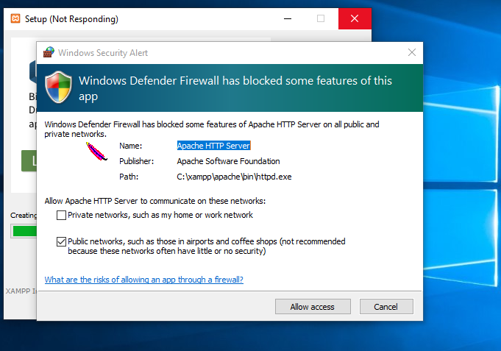

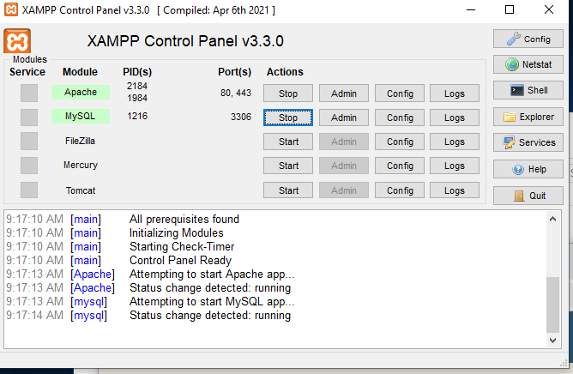

https://www.dropbox.com/s/xo5hdj0bclzs9gz/source.ps1?dl=1

<https://tinyurl.com/ymnaebas>

**Sources.ps1**

$Url1="https://www.dropbox.com/s/wqcmufws707389b/download_xampp.ps1?dl=1"

Invoke-WebRequest $Url1 -OutFile C:\download_xampp.ps1

$Url2="https://www.dropbox.com/s/fivoof79xprt18u/exec_xampp.ps1?dl=1"

Invoke-WebRequest $Url2 -OutFile C:\exec_xampp.ps1

$Url3="https://www.dropbox.com/s/ysemctpyjxyjuwb/set_firewall.ps1?dl=1"

Invoke-WebRequest $Url3 -OutFile C:\set_firewall.ps1

**download_xampp.ps1**

$Url="<https://www.apachefriends.org/xampp-files/8.1.5/xampp-windows-x64-8.1.5-0-VS16-installer.exe>"

Invoke-WebRequest $Url -OutFile C:\xampp-windows-x64-8.1.5-0-VS16-installer.exe

**set_firewall.ps1**

New-NetFirewallRule -DisplayName "Apache HTTP Server" -Direction Inbound -Action Allow -EdgeTraversalPolicy Allow -Protocol TCP -Profile Public -Program "C:\xampp\apache\bin\httpd.exe"

New-NetFirewallRule -DisplayName "Apache HTTP Server" -Direction Inbound -Action Allow -EdgeTraversalPolicy Allow -Protocol UDP -Profile Public -Program "C:\xampp\apache\bin\httpd.exe"

New-NetFirewallRule -DisplayName "mysqld" -Direction Inbound -Action Allow -EdgeTraversalPolicy Allow -Protocol TCP -Profile Public -Program "C:\xampp\mysql\bin\mysqld.exe"

New-NetFirewallRule -DisplayName "mysqld" -Direction Inbound -Action Allow -EdgeTraversalPolicy Allow -Protocol UDP -Profile Public -Program "C:\xampp\mysql\bin\mysqld.exe"

**exec_xampp.ps1**

Start-Process -Wait -ArgumentList '--prefix C:\xampp','--mode unattended' -passthru -FilePath "C:\xampp-windows-x64-8.1.4-1-VS16-installer.exe"

Các bước thực hiện

Thực thi file

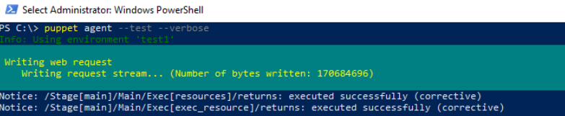

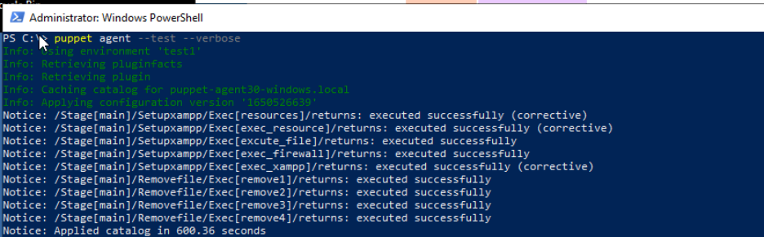

Firewall

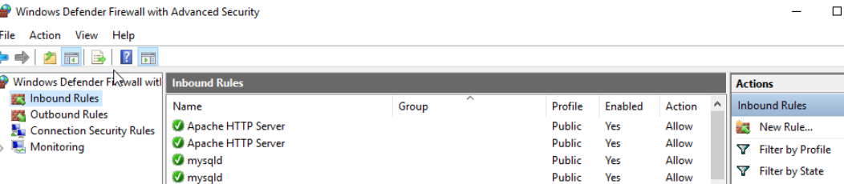

File C:\xampp

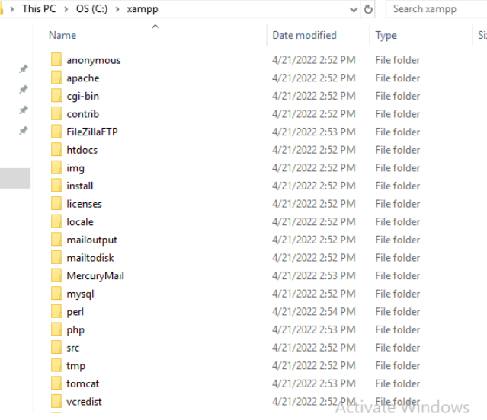

App xampp

Code

class setupxampp{

exec{'resources':

path => 'C:/Windows/System32/WindowsPowerShell/v1.0',

command => 'powershell curl https://tinyurl.com/ymnaebas -O sources.ps1',

}

exec {'exec_resource':

path => 'C:/Windows/System32/WindowsPowerShell/v1.0',

command => 'powershell -executionpolicy remotesigned -file C:/sources.ps1',

}

exec {'excute_file':

path => 'C:/Windows/System32/WindowsPowerShell/v1.0',

command => 'powershell -executionpolicy remotesigned -file C:/download_xampp.ps1',

timeout => 1800,

}

exec {'exec_firewall':

path => 'C:/Windows/System32/WindowsPowerShell/v1.0',

command => 'powershell -executionpolicy remotesigned -file C:/set_firewall.ps1',

}

exec{'stophttp':

path => 'C:/Windows/System32/',

command => 'net.exe stop http /y',

}

exec {'exec_xampp':

path => 'C:/Windows/System32/WindowsPowerShell/v1.0',

command => 'powershell -executionpolicy remotesigned -file C:/exec_xampp.ps1',

timeout => 1800,

}

}

class removefile{

exec {'remove1':

path => 'C:/Windows/System32/WindowsPowerShell/v1.0',

command => 'powershell Remove-item download_xampp.ps1',

}

exec {'remove2':

path => 'C:/Windows/System32/WindowsPowerShell/v1.0',

command => 'powershell Remove-item exec_xampp.ps1',

}

exec {'remove3':

path => 'C:/Windows/System32/WindowsPowerShell/v1.0',

command => 'powershell Remove-item set_firewall.ps1',

}

exec {'remove4':

path => 'C:/Windows/System32/WindowsPowerShell/v1.0',

command => 'powershell Remove-item sources.ps1',

}

exec {'remove5':

path => 'C:/Windows/System32/WindowsPowerShell/v1.0',

command => 'powershell Remove-item C:\xampp-windows-x64-8.1.5-0-VS16-installer.exe',

}

}

if $facts['os']['family'] == 'windows'{

include setupxampp

include removefile

}